Test Case: tc001_SPX_Dev5_Crear_Nueva_Linea_Requisicion_Spot_Tipo_Cobro_CC
Step 1 - Enter username and password and click to button Enter : Credentials Entered
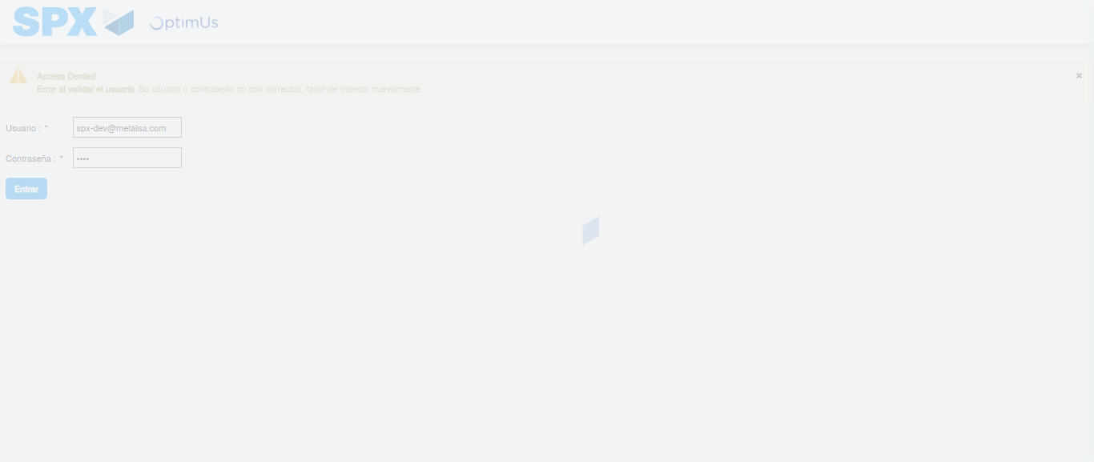Image file-name: QC_Testing-tc001_SPX_Dev5_Crear_Nueva_Linea_Requisicion_Spot_Tipo_Cobro_CC-1789494870556

Step 2 - Select to UEN and Access to Spot Buy Requisitions : UEN Correctly selected and Correct access
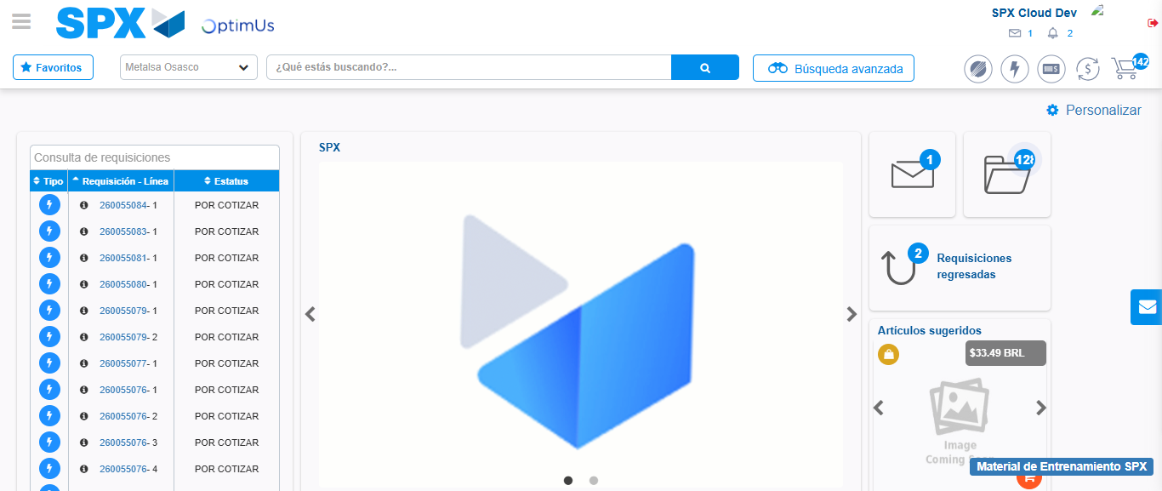Image file-name: QC_Testing-tc001_SPX_Dev5_Crear_Nueva_Linea_Requisicion_Spot_Tipo_Cobro_CC-1789494894563

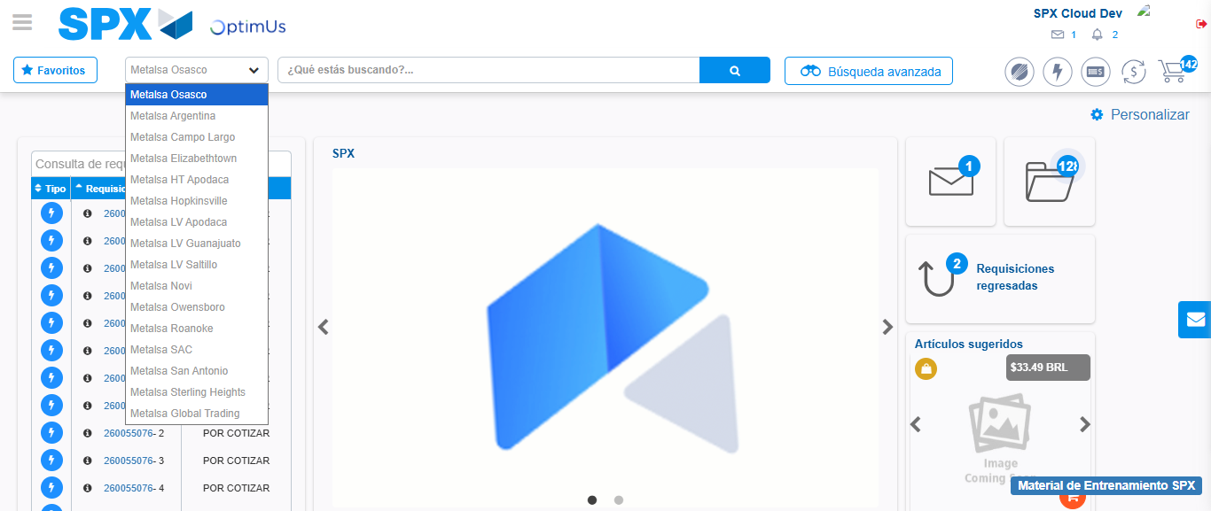Image file-name: QC_Testing-tc001_SPX_Dev5_Crear_Nueva_Linea_Requisicion_Spot_Tipo_Cobro_CC-1789494895523

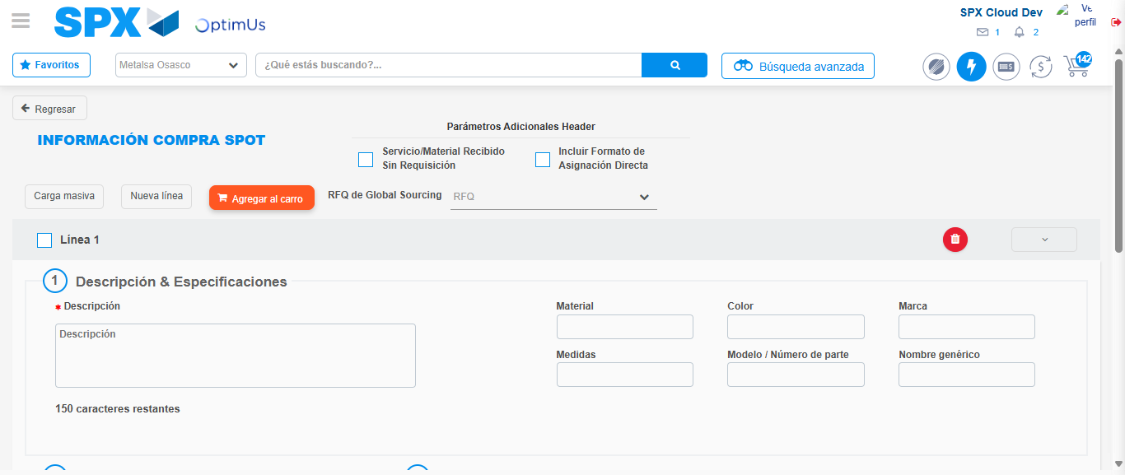Image file-name: QC_Testing-tc001_SPX_Dev5_Crear_Nueva_Linea_Requisicion_Spot_Tipo_Cobro_CC-1789494900947

Step 3 - Data Capture Spot Buy Requisition: Data captured correctly
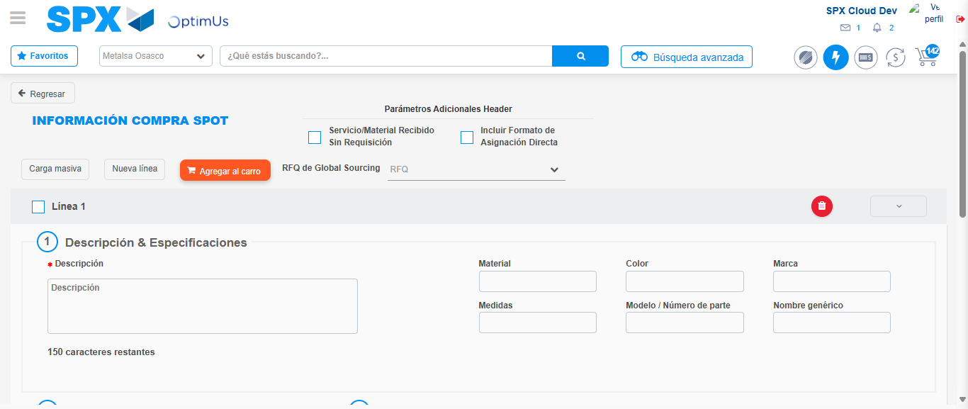Image file-name: QC_Testing-tc001_SPX_Dev5_Crear_Nueva_Linea_Requisicion_Spot_Tipo_Cobro_CC-1789494901273

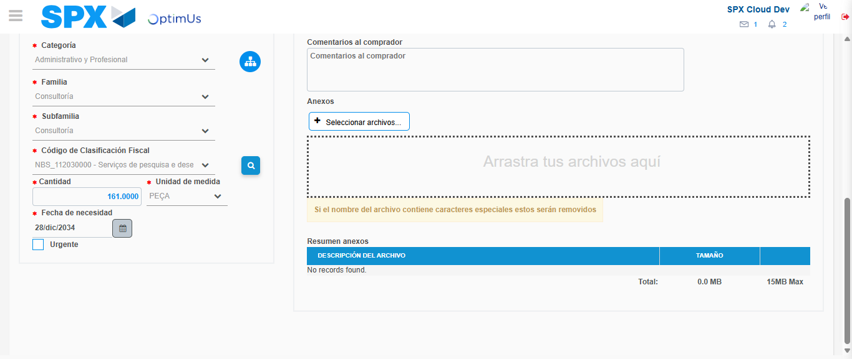Image file-name: QC_Testing-tc001_SPX_Dev5_Crear_Nueva_Linea_Requisicion_Spot_Tipo_Cobro_CC-1789494932033

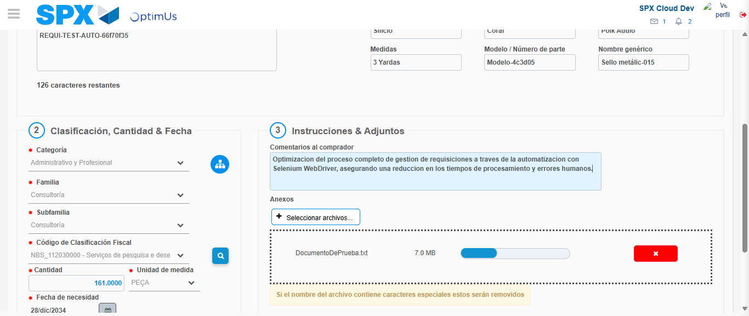Image file-name: QC_Testing-tc001_SPX_Dev5_Crear_Nueva_Linea_Requisicion_Spot_Tipo_Cobro_CC-1789494933020

Step 4 - Add new line and data capture second line: Line add correctly
Image file-name: QC_Testing-tc001_SPX_Dev5_Crear_Nueva_Linea_Requisicion_Spot_Tipo_Cobro_CC-1789494901273

Image file-name: QC_Testing-tc001_SPX_Dev5_Crear_Nueva_Linea_Requisicion_Spot_Tipo_Cobro_CC-1789494932033

Image file-name: QC_Testing-tc001_SPX_Dev5_Crear_Nueva_Linea_Requisicion_Spot_Tipo_Cobro_CC-1789494933020

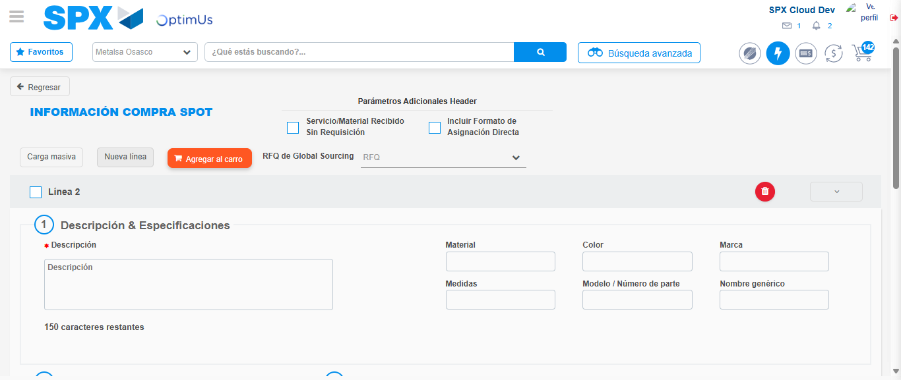Image file-name: QC_Testing-tc001_SPX_Dev5_Crear_Nueva_Linea_Requisicion_Spot_Tipo_Cobro_CC-1789494935410

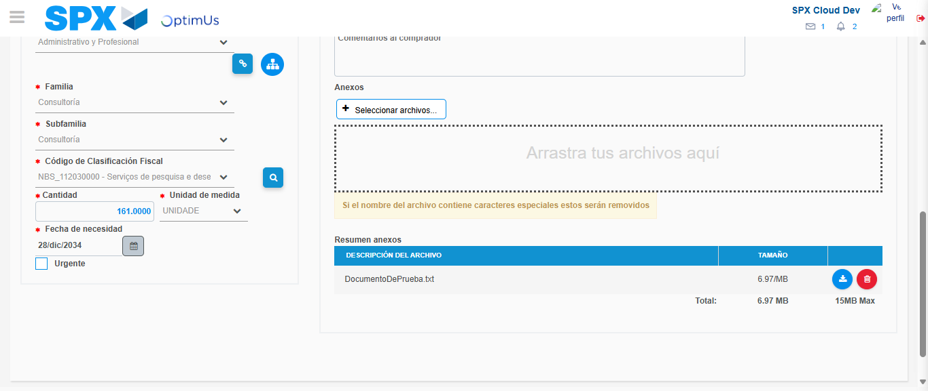Image file-name: QC_Testing-tc001_SPX_Dev5_Crear_Nueva_Linea_Requisicion_Spot_Tipo_Cobro_CC-1789494954427

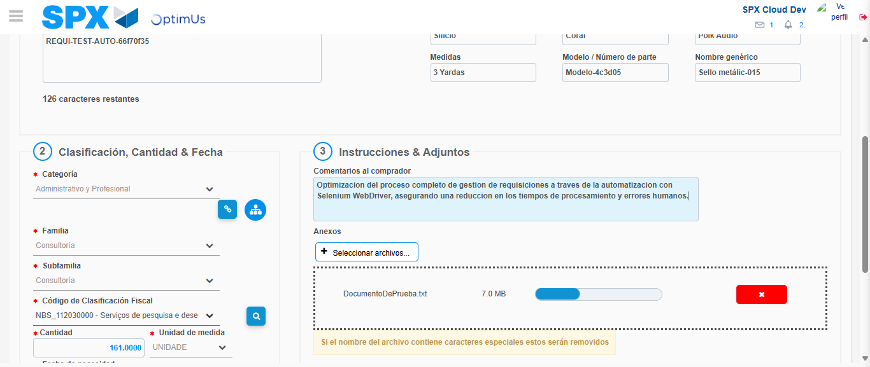Image file-name: QC_Testing-tc001_SPX_Dev5_Crear_Nueva_Linea_Requisicion_Spot_Tipo_Cobro_CC-1789494955380

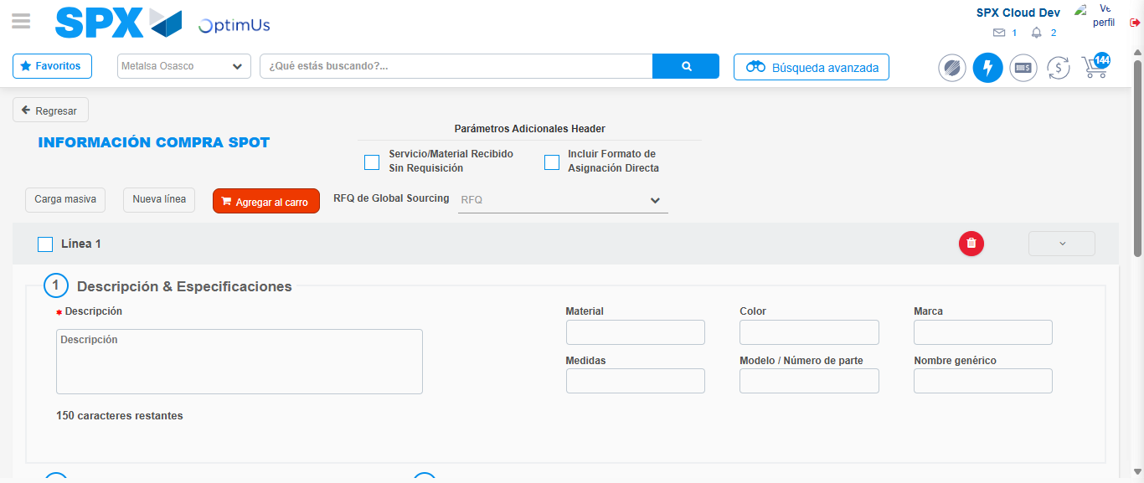Image file-name: QC_Testing-tc001_SPX_Dev5_Crear_Nueva_Linea_Requisicion_Spot_Tipo_Cobro_CC-1789494962225

Step 5 - Select to Requisition: Requisition Correctly selected
Image file-name: QC_Testing-tc001_SPX_Dev5_Crear_Nueva_Linea_Requisicion_Spot_Tipo_Cobro_CC-1789494962446

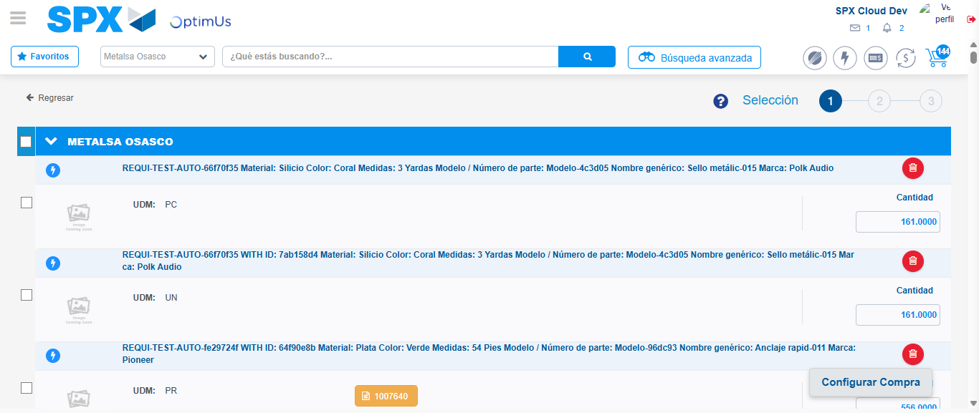Image file-name: QC_Testing-tc001_SPX_Dev5_Crear_Nueva_Linea_Requisicion_Spot_Tipo_Cobro_CC-1789494969141

Image file-name: QC_Testing-tc001_SPX_Dev5_Crear_Nueva_Linea_Requisicion_Spot_Tipo_Cobro_CC-1789494969494

Image file-name: QC_Testing-tc001_SPX_Dev5_Crear_Nueva_Linea_Requisicion_Spot_Tipo_Cobro_CC-1789494969778

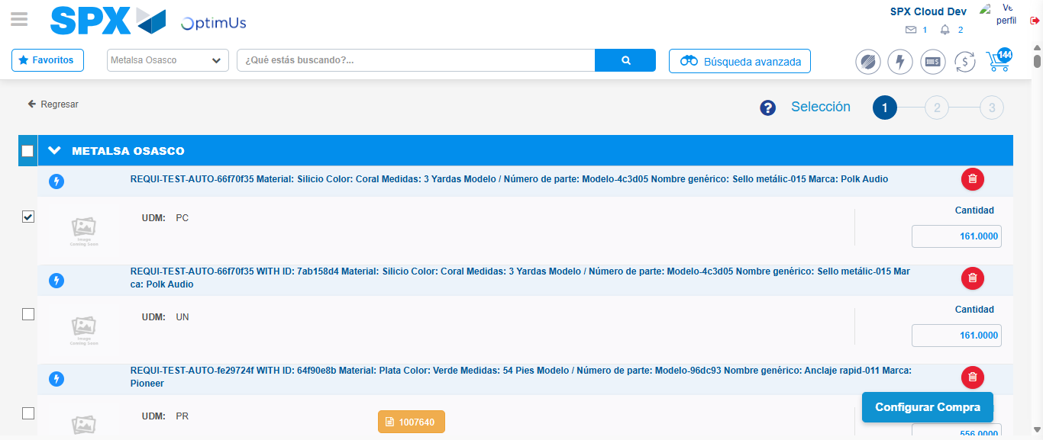Image file-name: QC_Testing-tc001_SPX_Dev5_Crear_Nueva_Linea_Requisicion_Spot_Tipo_Cobro_CC-1789494971309

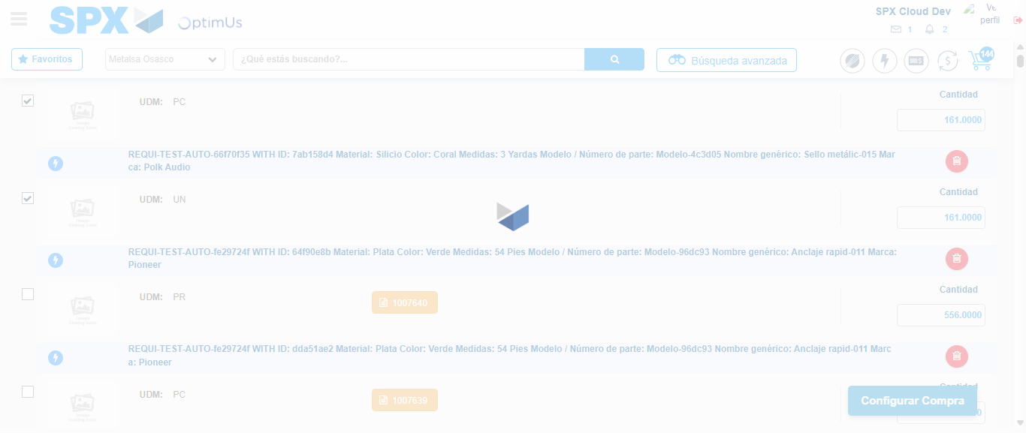Image file-name: QC_Testing-tc001_SPX_Dev5_Crear_Nueva_Linea_Requisicion_Spot_Tipo_Cobro_CC-1789494972922

Step 6 - Select Type Account For Requisition: Type Account Correctly selected
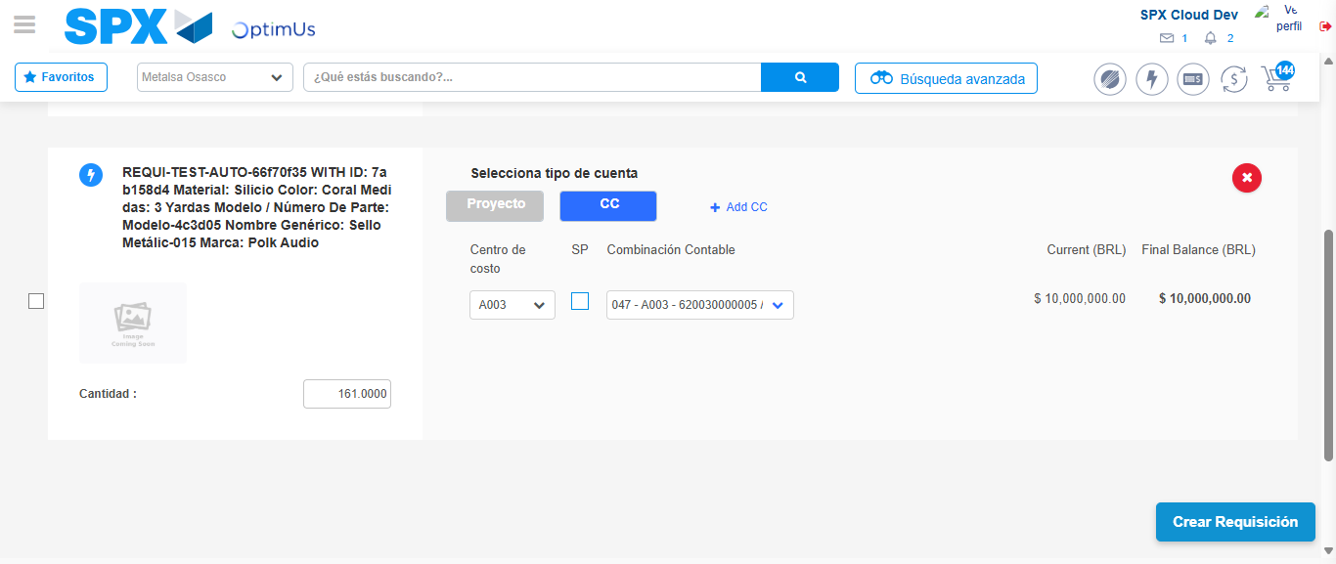Image file-name: QC_Testing-tc001_SPX_Dev5_Crear_Nueva_Linea_Requisicion_Spot_Tipo_Cobro_CC-1789495020098

Image file-name: QC_Testing-tc001_SPX_Dev5_Crear_Nueva_Linea_Requisicion_Spot_Tipo_Cobro_CC-1789495020337

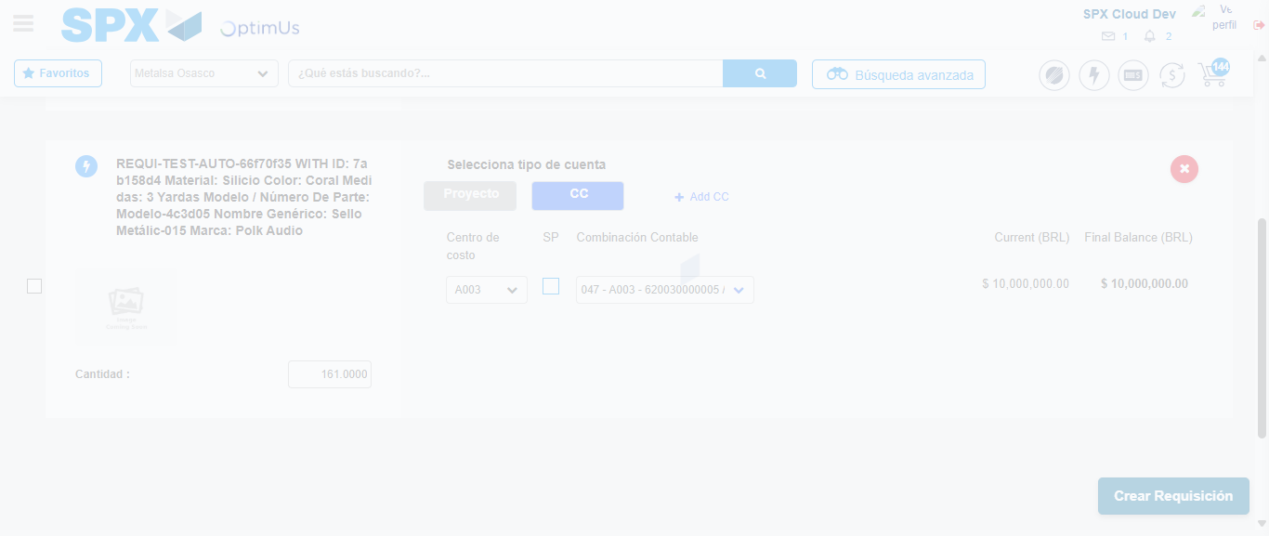Image file-name: QC_Testing-tc001_SPX_Dev5_Crear_Nueva_Linea_Requisicion_Spot_Tipo_Cobro_CC-1789495020812

Step 7 - Accept to Requisition: Requisition Accepted
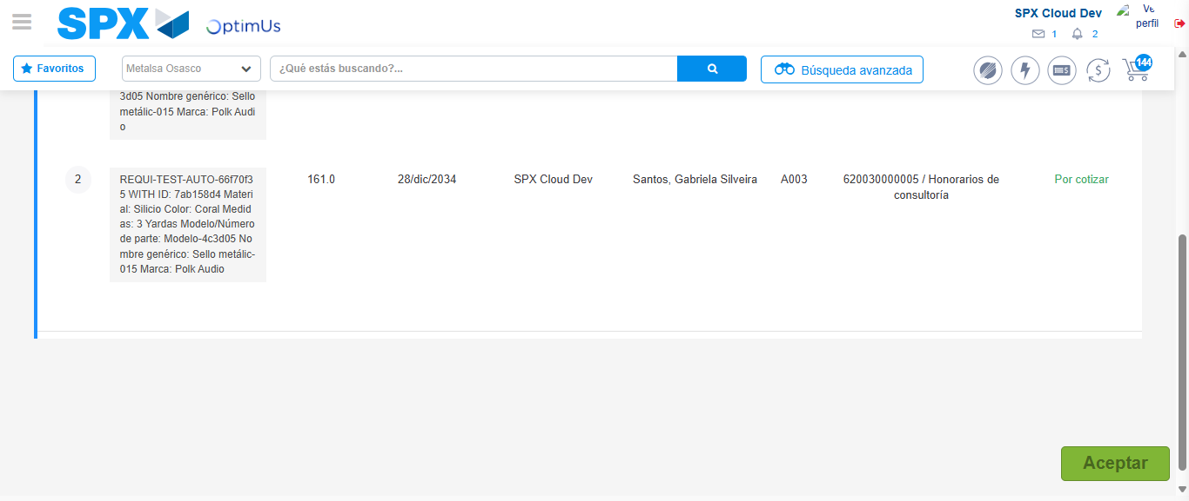Image file-name: QC_Testing-tc001_SPX_Dev5_Crear_Nueva_Linea_Requisicion_Spot_Tipo_Cobro_CC-1789495022231

Image file-name: QC_Testing-tc001_SPX_Dev5_Crear_Nueva_Linea_Requisicion_Spot_Tipo_Cobro_CC-1789495022494

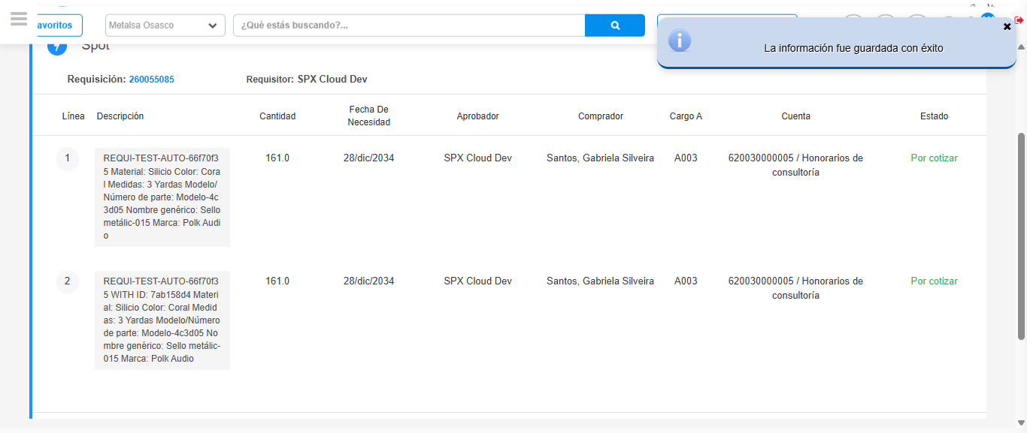Image file-name: QC_Testing-tc001_SPX_Dev5_Crear_Nueva_Linea_Requisicion_Spot_Tipo_Cobro_CC-1789495026071

Step 8 - Return to Main Page SPX : Return to Main Page SPX
Image file-name: QC_Testing-tc001_SPX_Dev5_Crear_Nueva_Linea_Requisicion_Spot_Tipo_Cobro_CC-1789494894563

Image file-name: QC_Testing-tc001_SPX_Dev5_Crear_Nueva_Linea_Requisicion_Spot_Tipo_Cobro_CC-1789494895523

Image file-name: QC_Testing-tc001_SPX_Dev5_Crear_Nueva_Linea_Requisicion_Spot_Tipo_Cobro_CC-1789494900947

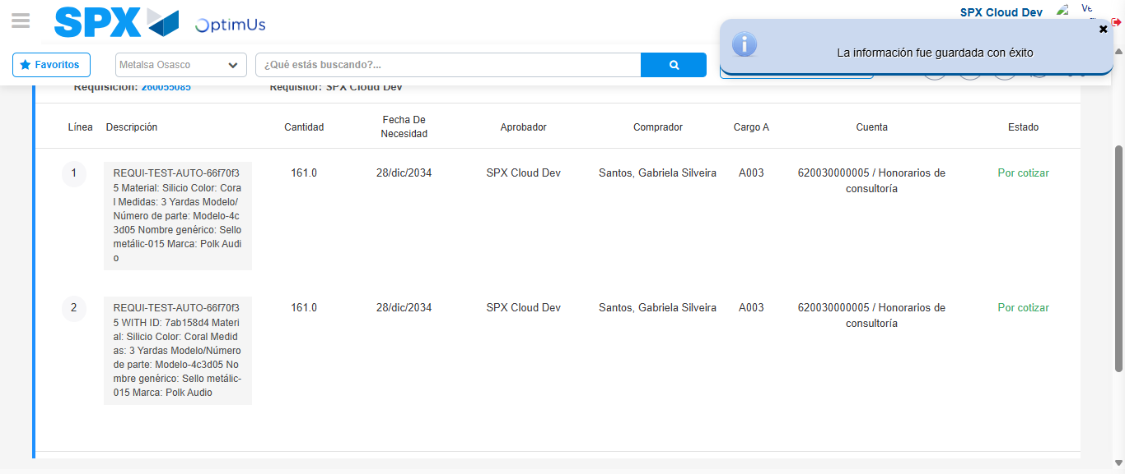Image file-name: QC_Testing-tc001_SPX_Dev5_Crear_Nueva_Linea_Requisicion_Spot_Tipo_Cobro_CC-1789495028352

Image file-name: QC_Testing-tc001_SPX_Dev5_Crear_Nueva_Linea_Requisicion_Spot_Tipo_Cobro_CC-1789495028604

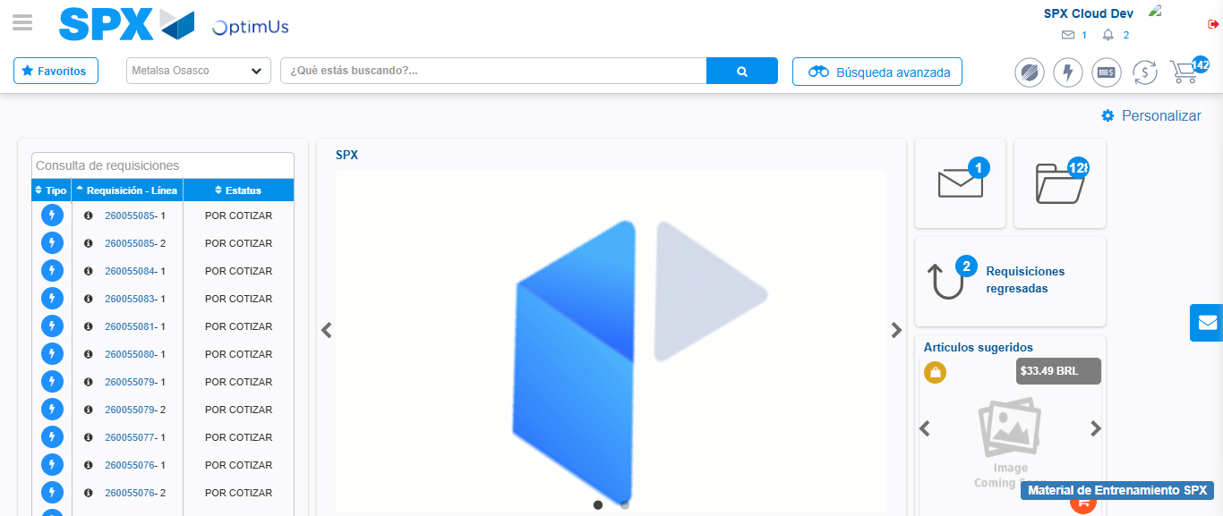Image file-name: QC_Testing-tc001_SPX_Dev5_Crear_Nueva_Linea_Requisicion_Spot_Tipo_Cobro_CC-1789495050040

Step 9 - Log Out : Log Out SPX
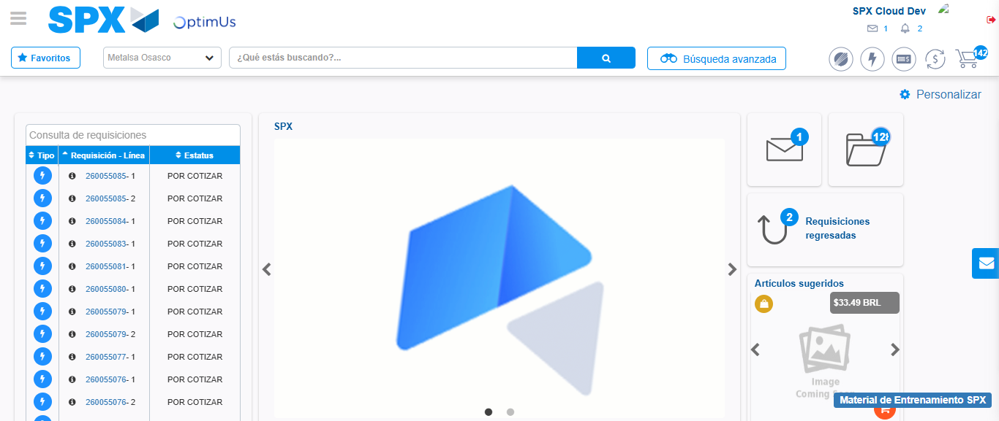Image file-name: QC_Testing-tc001_SPX_Dev5_Crear_Nueva_Linea_Requisicion_Spot_Tipo_Cobro_CC-1789495050320

